________________________________________________________________________
Model: C:\TEMP\UML_Model.mdl

DEPLOYMENT VIEW

Table of Contents

1. Table of Contents 2
2. List of Figures 3
3. Deployment View 4
3.1. Application Processor 4
3.2. Application Processor 4
3.3. SMST Application Processor 4

List of Figures

Figure 1. Deployment View (Deployment Diagram) 4

Deployment View

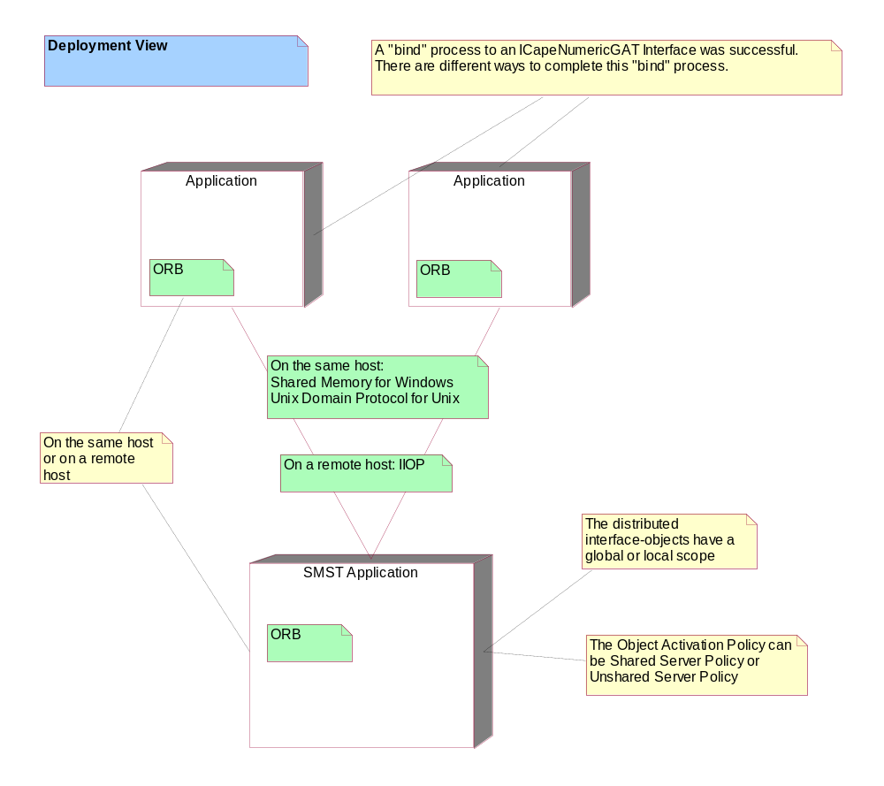
Figure 1. Deployment View (Deployment Diagram)

Application Processor

Application Processor

SMST Application Processor

